**St. Xavier’s College**

**(Affiliated to Tribhuvan University)**

**Maitighar, Kathmandu**



**COMPUTER GRAPHICS**

**LAB ASSIGNMENT #6**

**TO IMPLEMENT MID POINT ELLIPSE ALGORITHM**

**Submitted By**

Tej Bahadur Saru

013BSCCSIT044

**Submitted To**

|  |  |
| --- | --- |
| Er. Anil K Shah  Lecturer, St. Xavier’s College |  |

Department of Computer Science

Date of Submission: 25th Aug, 2015

**STATEMENT:**

**WRITE A PROGRAM TO IMPLEMENT MID POINT ELLIPSE ALGORITHM IN C++ BUILDER.**

**ALGORITHM:**

**Step 1:** input center (xc,yc) and rx and ry for the ellipse and obtain the first point as (x0,y0)=(0, ry)

**Step 2:** calculate initial decision parameter value in region 1 as

P10=

**Step 3:** at each xk­ position, in region1, starting at k=0, compute

xk+1=xk+1

if p1k=p1k+2xk+1+

yk+1=yk+1

otherwise next point to plot is

yk+1=yk-1

P1k+1=P1k+xk+1+-2yk+1 with xk+1=xk+1 and yk+1=yk-1

**Step 4:** calculate the initial value of decision parameter at region 2 using last calculated point say(x0,y0) in region 1 as

P20=

**Step 5:** at each yk position in region 2 starting at k=0, perform computation

yk+1=y-1

if P2k>0, then

xk+1=xk

P2k+1=P2k-

Otherwise

xk+1=xk+1

P2k+1=P2k+2 where xk+1=xk+1 and yk+1=yk+1

**Step 6:** determine the symmetry points in other three quadrants.

**Step 7:** move each calculated point (xk,yk) on to the centered (xc,yc) ellipse path as

xk=xk+xc

yk=yk+yc

**Step 8:** repeat the process for region 1 until and region 2 until (xk,yk)=(rx,0).

**SOURCE CODE:**

#include <vcl\vcl.h>

#pragma hdrstop

#include "elip.h"

//---------------------------------------------------------------------------

#pragma resource "*.dfm"

TForm1 *Form1;

//---------------------------------------------------------------------------

__fastcall TForm1::TForm1(TComponent* Owner)

: TForm(Owner)

{

}

//---------------------------------------------------------------------------

void __fastcall TForm1::DrawClick(TObject *Sender)

{

int xc,yc,rx,ry;

xc = StrToInt(Edit1->Text);

yc = StrToInt(Edit2->Text);

rx = StrToInt(Edit3->Text);

ry = StrToInt(Edit4->Text);

int x, y, p;

x=0; //Initial Coordinates

y=ry; //Initial Coordinates

p=(ry*ry)-(rx*rx*ry)+((rx*rx)/4); // Intial Decision Parameter for Region 1

while((2*x*ry*ry)<(2*y*rx*rx))

{ //Region 1 with Symmertic Property

Image1->Canvas->Pixels[xc+x][yc-y]=RGB(255,0,0);

Image1->Canvas->Pixels[xc-x][yc+y]=RGB(0,255,0);

Image1->Canvas->Pixels[xc+x][yc+y]=RGB(0,0,255);

Image1->Canvas->Pixels[xc-x][yc-y]=RGB(2055,155,0);

if(p<0)

{

x=x+1;

p+=(2*ry*ry*x)+(ry*ry);

}

else

{

x=x+1;

y=y-1;

p+=(2*ry*ry*x+ry*ry)-(2*rx*rx*y);

}

}

p=((float)x+0.5)*((float)x+0.5)*ry*ry+(y-1)*(y-1)*rx*rx-rx*rx*ry*ry; // Intial Decision parameter for Region 2

while(y>=0)

{

//Region 2 with Symmertic Property

Image1->Canvas->Pixels[xc+x][yc-y]=RGB(255,120,255);

Image1->Canvas->Pixels[xc-x][yc+y]=RGB(100,255,130);

Image1->Canvas->Pixels[xc+x][yc+y]=RGB(110,155,255);

Image1->Canvas->Pixels[xc-x][yc-y]=RGB(123,145,185);

if(p>0)

{

y=y-1;

p-=(2*rx*rx*y)+(rx*rx);

}

else

{

y=y-1;

x=x+1;

p+=(2*ry*ry*x)-(2*rx*rx*y)-(rx*rx);

}

}

}

//------------------------------------------------------------------

**OUTPUT SCREEN**

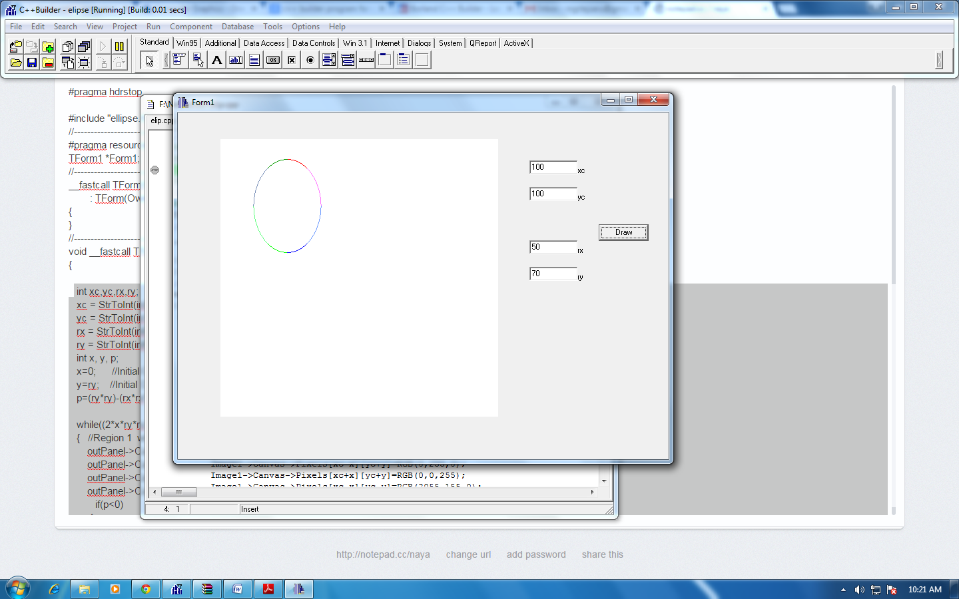

**CONCLUSION**

Hence, the mid point ellipse algorithm was implemented in C++ Builder according to the given centre and radius.